EXCEL ASSIGNMENT 16

***1.What is a Macro? How is it useful in excel or in your daily work?***

* Macro is a synonym for VBA.

VBA = Visual Basic Application = Macro = written code that executes commands to do things in excel.

* Macro allows you to perform multiple operations just by clicking a simple button.
* It enables you to work in a smart and efficient way.
* Macros for Excel are instructions you can customise to complete repetitive tasks automatically. Implementing macros in different types of software can help save users time when working on repetitive tasks, like filling in cells.

*Advantages of using macros in excel :-*

1. **Increased productivity** – Macros can automate repetitive tasks, allowing users to complete tasks more quickly and efficiently.
2. **Enhanced accuracy** – Macros can reduce the risk of errors by consistently following a set of predetermined steps.
3. **Customization** – Macros can be customized to fit the specific needs of a user or organization, allowing for greater flexibility and control.
4. **Ease of use** – Macros can be created and edited using simple commands, making them accessible to users of all skill levels.
5. **Compatibility** – Macros can be used across a range of applications and devices, making them a versatile tool for productivity.

***2. What is VBA? Write its full form and briefly explain why VBA is used in excel?***

* ***Ans.*** Visual Basic for Applications is a computer programming language developed and owned by Microsoft.
* With VBA you can create macros to automate repetitive word- and data-processing functions, and generate custom forms, graphs, and reports.
* VBA functions within MS Office applications; it is not a stand-alone product.
* VBA is accessed in Excel by hitting Alt + F11 while having an Excel workbook present.
* VBA leverages objects, variables, properties, projects, logical operators, and modules to make statements recognizable by debugging processes.

VBA is used to further expand what some programs are able to accomplish. VBA is often used to create macros, automate processes, generate custom forms, or perform repetitive tasks that may need minimal human intervention.

***3. How do you record a macro? Write detailed steps to create a macro to automatically make the following table in bold and to create borders for it in excel.***

***hi 78***

***hello 69***

***ineuron 45***

***ans.*** Here are the steps to record this macro:

1. Click the Developer tab.
2. In the Code group, click on the Macro button. This will open the ‘Record Macro’ dialog box.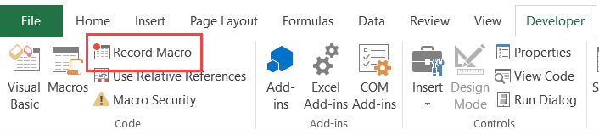
3. In the Record Macro dialog box, enter a name for your macro. I am using the name **EnterText**. There are some naming conditions that you need to follow when naming a macro. For example, you can not use spaces in between. I usually prefer to keep my macro names as a single word, with different parts with a capitalized first alphabet. You can also use underscore to separate two words – such as Enter_Text.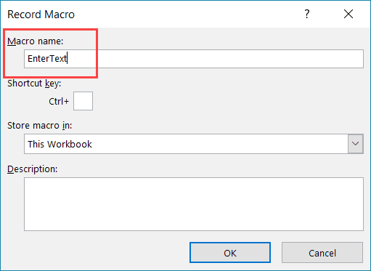
4. (Optional Step) You can assign a keyboard shortcut if you want. In this case, we will use the shortcut Control + Shift + N. Remember that the shortcut you assign here would override any existing shorcuts in your workbook. For example, if you assign the shortcut Control + S, you will not be able to use this for saving the workbook (instead, everytime you use it, it will execute the macro).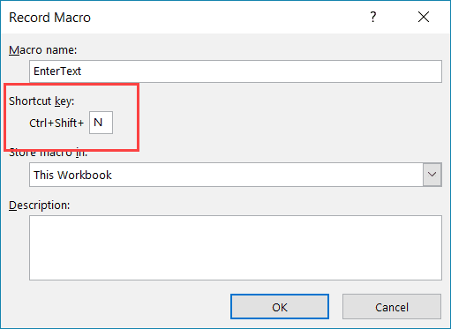
5. In the ‘Store macro in’ option, make sure ‘This Workbook’ is selected. This step ensures that the macro is a part of the workbook. It will be there when you save it and reopen again, or even if you share it with someone.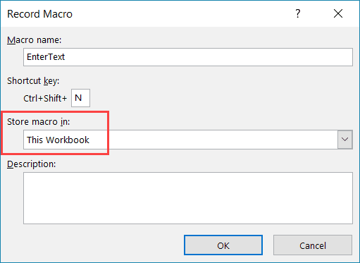
6. (Optional Step) Enter a description. I usually don’t do this, but if you’re extremely organized, you may want to add what the macro is about.
7. Click OK. As soon as you click OK, it starts to record your actions in Excel. You can see the ‘Stop recording’ button in the Developer tab, which indicates that the macro recording is in progress.
8. Select cell A2.
9. Enter the text **Excel**(or you can use your name).
10. Hit the Enter key. This will select cell A3.
11. Click on the Stop Recording button the Developer tab.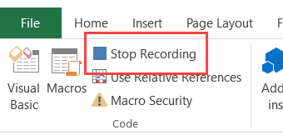

***4. What do you mean when we say VBA Editor?***

***Ans.*** Excel’s Visual Basic for Applications (VBA) editor is a very powerful tool.

It lets you write and edit**custom scripts that automate actions in Excel.**

In fact, when you record a macro it is stored in VBA code in the VBA editor.

But writing a macro from the VBA editor directly gives you more flexibility than recording a macro in the traditional manner.

You can create better VBA code and complete more complicated tasks by working directly with Visual Basic for Applications.

***5. Briefly describe the interface of a VBA editor? What is properties***

***window? And what is watch window? How do you display these windows?***

***Ans.*** The Properties window is used to display properties for objects selected in the two main types of windows available in the Visual Studio integrated development environment (IDE). These two types of windows are: Tool windows such as Solution Explorer, Class View, and Object browser.

The Watch Window makes it convenient to inspect, audit, or confirm formula calculations and results in large worksheets. By using the Watch Window, you don't need to repeatedly scroll or go to different parts of your worksheet. This toolbar can be moved or docked like any other toolbar.

* To display the Properties windows, on the main menu, click View -> Properties Window

|  |
| --- |
| Empty Fields |
|  |

|  |  |
| --- | --- |
| Property Empty | By default, these fields have nothing in their value section. Most of these properties are dependent on other settings of your program. For example, you can set a menu property for a form only after you have created a menu.  To set the property on such a field, you can type in it or select from a list. |

1. ***What is an immediate Window and what is it used for?***

***Ans.*** The Immediate window evaluates expressions by building and using the currently selected project. To display the Immediate window, open a project for editing, and then choose Debug > Windows > Immediate or press Ctrl+Alt+I. You can also enter Debug. Immediate in the Command window.